VM Deployment with Auto-Scaling and Security on Google Cloud
By
Harika Korivi(M25AI2132)
1. Introduction
Cloud computing platforms provide organizations with the ability to deploy infrastructure that is scalable, flexible, and secure without investing in physical hardware. In this project, a virtual machine environment was created using the Compute Engine service in Google Cloud Platform (GCP).
The primary objective was to build a VM-based infrastructure that supports centralized configuration, secure access management, controlled network communication, and scalable workload handling.
The implementation was carried out in a structured sequence:
- Creation of a Service Account
- Creation of an Instance Template and assignment of the Service Account
- Configuration of firewall rules
- IAM role configuration
- Creation of a Managed Instance Group
- Verification of VM instances
Each of these steps contributes to building a secure and production-ready cloud architecture.

2. Creation of Service Account
The first step in the implementation process was creating a Service Account. A Service Account acts as a non-human identity that virtual machines use to interact securely with other cloud services. Instead of embedding user credentials inside the VM, a Service Account ensures controlled and auditable access.
To create the Service Account, the IAM & Admin section of the console was accessed, and a new service account was defined with a meaningful name to reflect its purpose. While creating it, specific roles were assigned based on operational requirements. For example, roles such as Compute Viewer or Monitoring Viewer were granted to ensure the VM could access only the necessary services.
This step is crucial because it enforces the principle of least privilege. The virtual machines receive only the permissions required for their functionality, reducing the risk of misuse or unauthorized access.
By completing this step first, the security foundation for the VM environment was established.
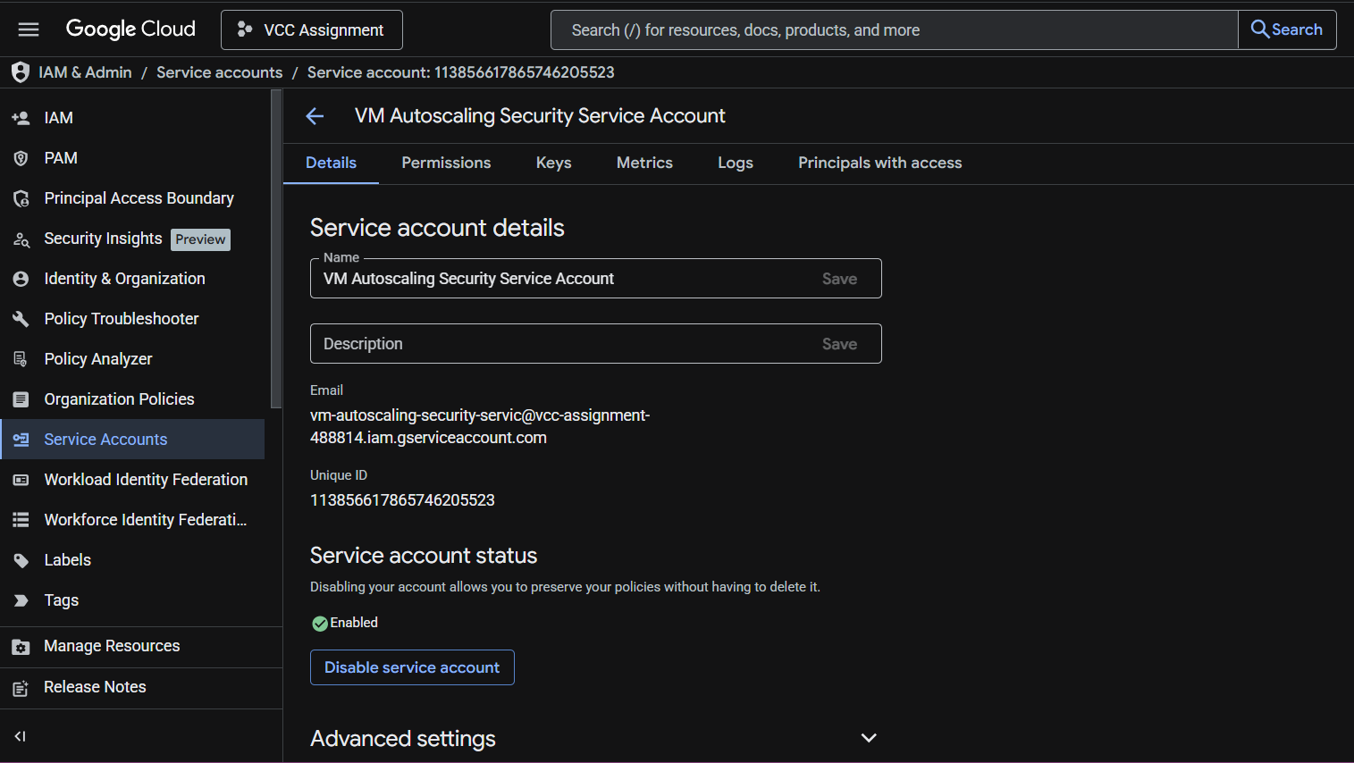
3. Creation of Instance Template
After setting up the Service Account, the next task was to create an Instance Template. An Instance Template acts as a blueprint that defines how virtual machines should be configured.
While creating the template in the Compute Engine section, configuration details such as machine type, boot disk operating system, and network settings were specified. A Linux-based OS (Debian/Ubuntu) was selected for the boot disk to ensure stability and compatibility.
The most important configuration in this step was assigning the previously created Service Account under the “Identity and API Access” section. This ensures that every VM created using this template automatically inherits the same security identity and permissions.
The purpose of using an Instance Template is consistency. Instead of manually configuring each virtual machine, the template guarantees uniform configuration across all instances. This is especially important in scalable environments where multiple VMs may be created dynamically.
At the end of this step, a standardized VM configuration model was successfully established.
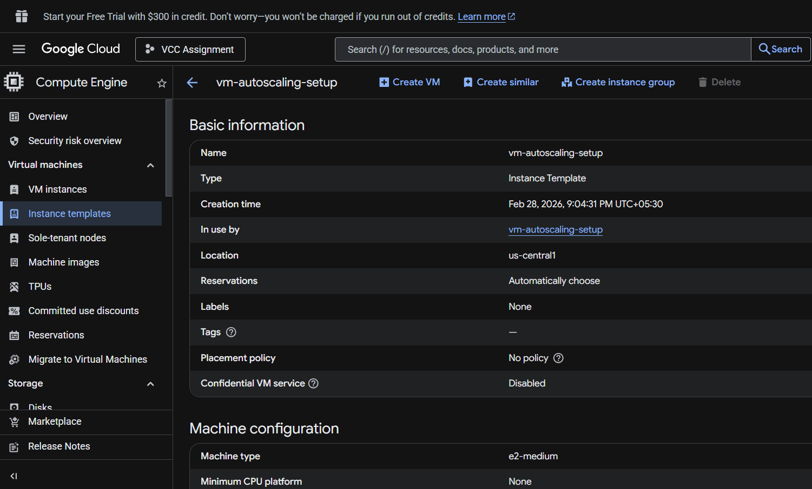
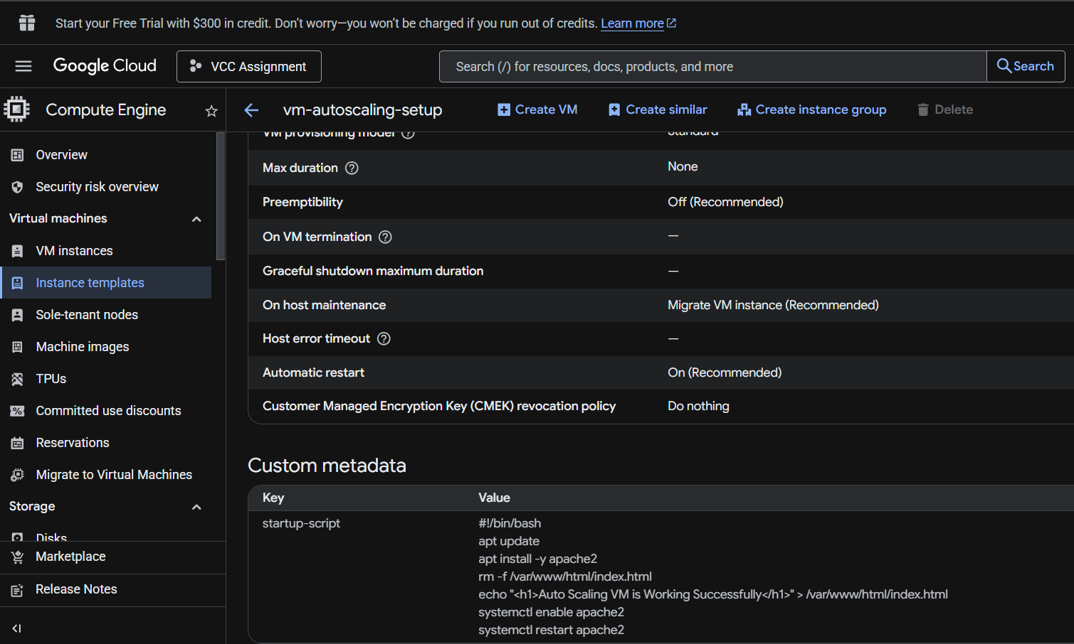
4. Firewall Rule Configuration
Security at the network level is equally important. Therefore, firewall rules were configured to regulate incoming traffic to the VM instances.
Firewall rules were created under the VPC Network section. Two types of rules were defined:
First, a rule was created to allow HTTP traffic on port 80 so that web services running on the VM could be accessed from the internet. This rule allowed inbound traffic from all IP ranges.
Second, SSH access was restricted. Instead of allowing SSH access from anywhere, it was limited to a specific IP address range. This significantly reduces the risk of unauthorized login attempts.
Firewall configuration ensures that:
- Only required ports are open
- Unnecessary traffic is blocked
- Attack surface is minimized
By carefully defining firewall rules, the VM environment was protected from unwanted network exposure.
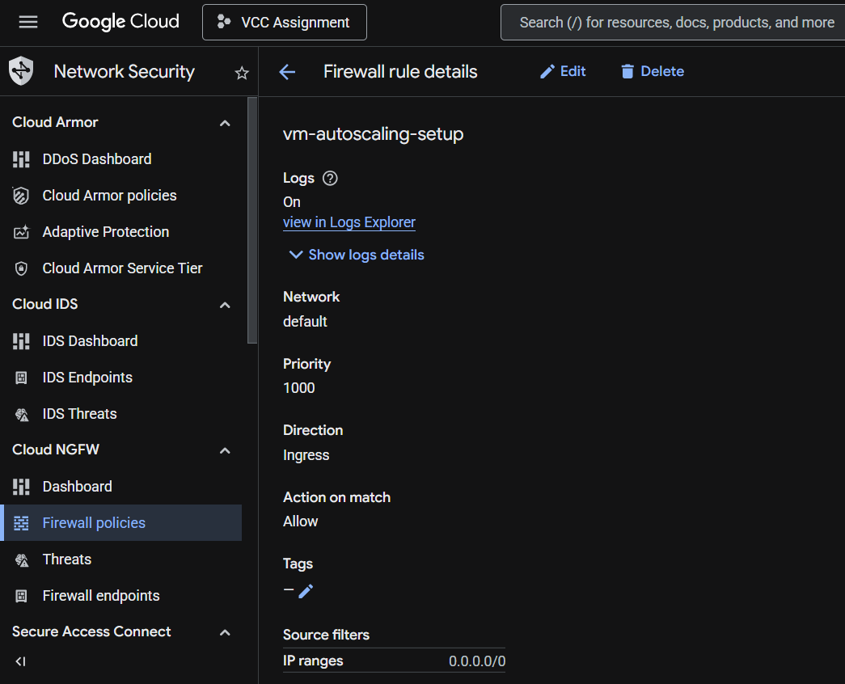
5. IAM Role Configuration
After securing network access, user-level access control was configured using Identity and Access Management (IAM).
IAM determines who can perform what action on cloud resources. In this step, specific users were granted access according to their roles. For example, a user requiring only monitoring access was assigned a Viewer role, while an administrator responsible for managing compute resources was assigned a Compute Admin role.
This separation of responsibilities ensures accountability and prevents excessive permissions. IAM plays a vital role in enterprise environments where multiple team members collaborate on cloud infrastructure.
By implementing IAM controls, the infrastructure became secure not only at the system level but also at the user access level.
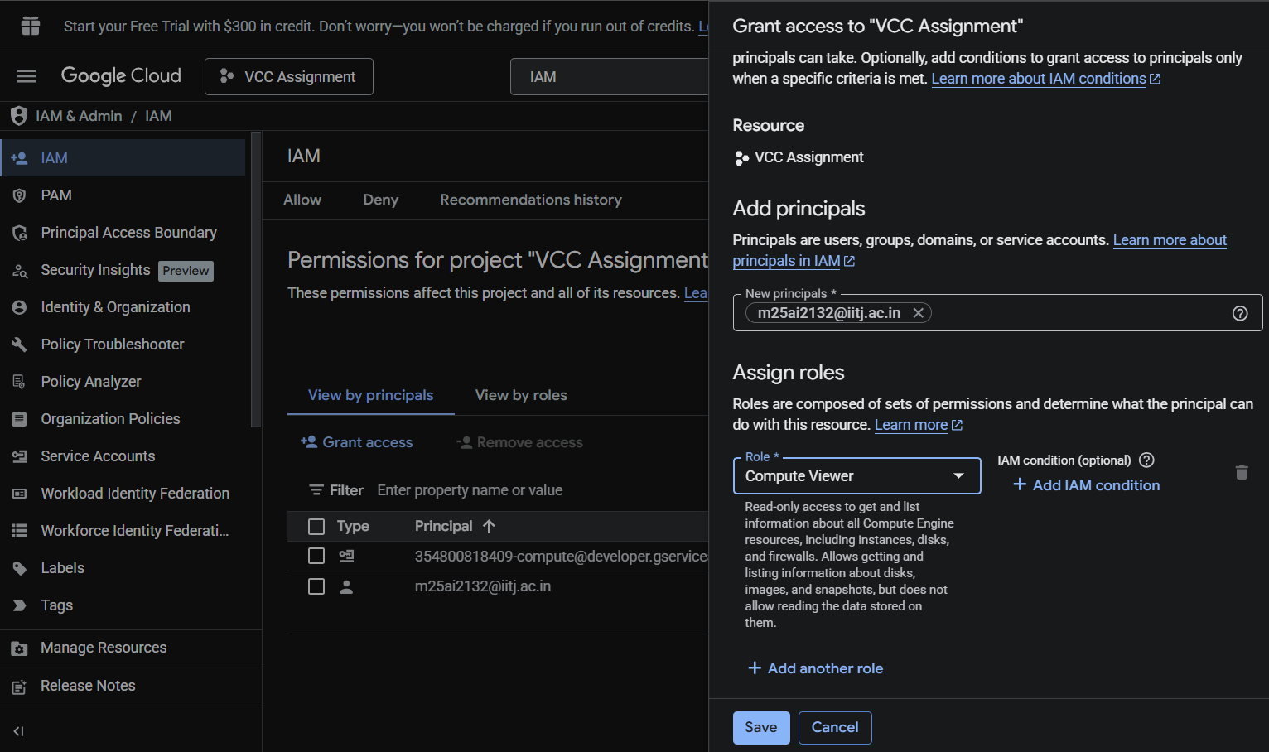
6. Creation of Managed Instance Group
Once the security and configuration foundation was ready, a Managed Instance Group (MIG) was created using the previously defined Instance Template.
A Managed Instance Group allows multiple VM instances to be created and managed collectively. Instead of manually creating and managing each VM, the group automates this process.
During configuration, the Instance Template was selected so that all instances would follow the predefined settings. The initial number of instances was specified, and optional auto-scaling policies were configured based on CPU utilization.
If auto-scaling was enabled, the system was set to:
- Increase instances when CPU usage exceeds a defined threshold
- Decrease instances when workload reduces
This dynamic scaling ensures efficient resource utilization. It improves performance during high demand while reducing cost during low usage.
The creation of the Managed Instance Group marked the transition from a single VM setup to a scalable infrastructure.
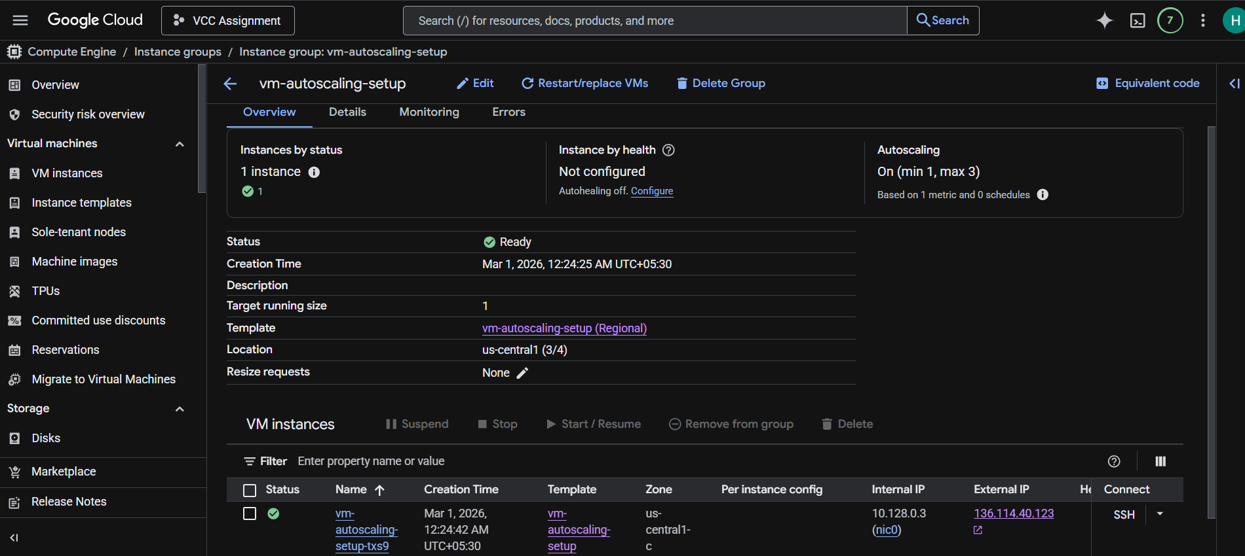
7. Verification of Virtual Machine Instances
After creating the Managed Instance Group, verification was performed to ensure that the configuration was successful.
The VM Instances section in Compute Engine was checked to confirm:
- Instances were in Running state
- Service Account was attached correctly
- Network and firewall rules were applied
- External IP addresses were assigned
SSH connectivity was tested to verify access. If a web server was configured, HTTP access was tested through the browser.
Monitoring dashboards were reviewed to observe CPU utilization and instance health status. This ensured that scaling policies, if configured, were functioning correctly.
Verification is an important final step because it confirms that both configuration and security measures are operational.
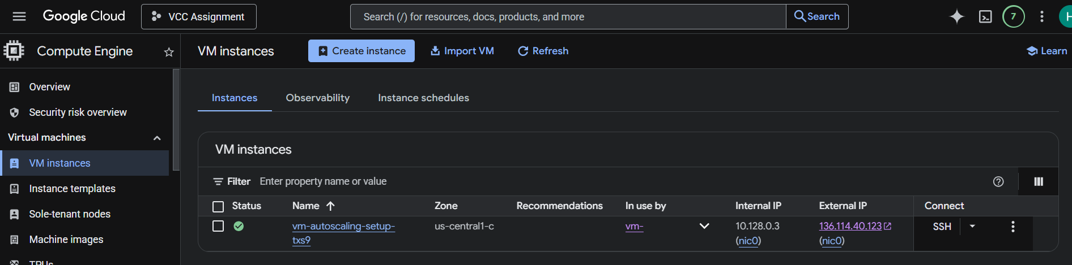

8. Architecture Explanation
The final architecture follows a structured flow.
Users access the system through the internet. The firewall filters incoming traffic based on defined rules. The Managed Instance Group handles VM instances created from the Instance Template. Each VM carries the assigned Service Account, and access to resources is controlled through IAM policies.
This layered design ensures:
- Network-level security (Firewall)
- Identity-level security (IAM and Service Account)
- Configuration consistency (Instance Template)
- Scalability (Managed Instance Group)
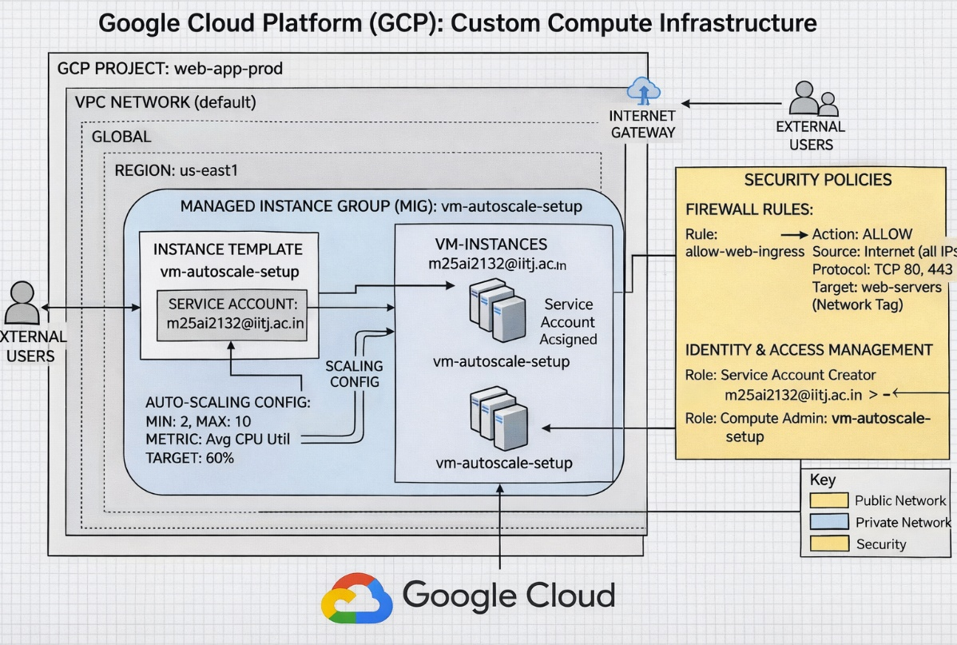
9. Conclusion
The project successfully demonstrates the deployment of a secure and scalable VM-based infrastructure using Compute Engine in Google Cloud Platform.
By integrating Service Accounts, IAM roles, firewall rules, and Managed Instance Groups, the system achieves:
- Controlled access management
- Secure network communication
- Centralized VM configuration
- Scalable resource allocation
This architecture reflects real-world cloud deployment practices and follows recommended security principles. It is suitable for hosting web applications, backend services, or enterprise workloads requiring reliability and flexibility.
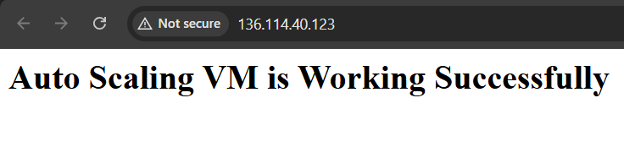
Google Drive link:
https://drive.google.com/file/d/1ucuGa1sp33cD9EAQM6rQAnG9NprkS0JI/view?usp=sharing
Git-hub Repository Link:
https://github.com/m25ai2132-ctrl/VCC-Assignment-2

